**Project Java**

**Physico Test Application**

**Name : Muhammad Naufal P.P.**

**Ugi Ispoyo Widodo**

**Faculty : Fachran Nazarullah S.Kom**

**Semester : 4**

**Quarter : 1**

**Class : 4SC2**

**Gedung Pascasarjana Lt. 3 Fakultas Teknik Universitas Indonesia**

**Kampus Baru UI Depok 16424**

**PROJECT ON**

**Psyco Test Application**

Developed By

Name : Ugi Ispoyo Widodo

Muhammad Naufal Pradimasty Pangestu

Reg. No : 1410010011

1410010014

**NIIT**

**PSYCO TEST APPLICATION**

**Batch Code :**

**Start Date :** March 21th 2016

**End Date :** March 29th 2016

**Name of Coordinator :** Fachran Nazarullah S.Kom

**Name of Developer :** Ugi Ispoyo Widodo

Muhammad Naufal P.P.

**Date of Submission :** March 30th 2016

**NIIT**

**CERTIFICATE**

This is certify that this report, titled Exam Application, embodies the original work done by **Ugi Ispoyo Widodo** and **Muhammad Naufal Pradimasty Pangestu** in partial fulfillment of their course requirement at NIIT

Coordinator:

Fachran Nazarullah S.Kom

**ACKNOWLEDGEMENT**

The Project presentation opportunity we have with CCIT-FTUI is a great chance for learning and professional development. Therefore, we consider ourselves very lucky as we are provided with an opportunity to be a part of it. We are also grateful for having a change to meet so many wonderful people and professionals who led us through this project period.

Bearing in mind, we would like to express our deepest gratitude and special thanks to Mr. Fachran Nazaruddin of CCIT-FTUI faculty who is spite of being extraordinarily busy with her duties, took time out to hear, guide and keep us on the correct path and allowing us to carry out our project until completion.

Our Project assignment won’t be as good as it is now without any help, feedback and suggestion that were given to us by our friends within the campus. So, we would also like to say thank you to all of them. We will strive to use gained skills and knowledge in the best possible way, and we will continue to work on the improvements, in order to attain desired carrer objective.

**SYSTEM ANALYSIS**

**System Summary:** Physco Test Application is a application that facilitates student to have a test without paper, to simpler the way of test system, calculates the score in instant and automatically sending the data to the database. The application stores the questions and the score of each student, so a student can see the score test easily.

**TECHNOLOGY DIAGRAM**

**Top Level Diagram representing the technologies used to develop application.**



**Java Application RMI Server Database Server**

**USE CASE DIAGRAM FOR PSYCO TEST APPLICATION**

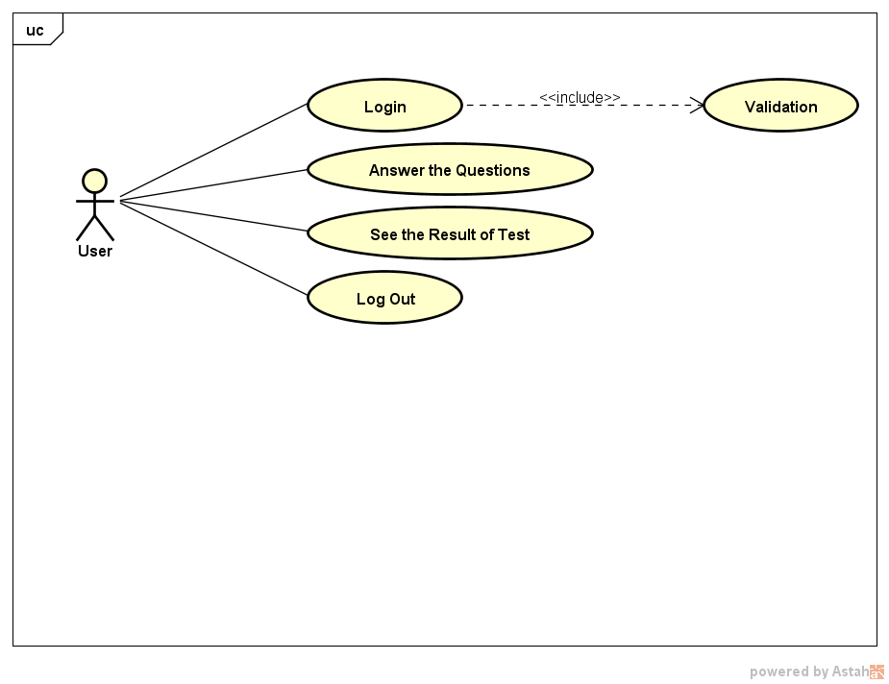

**CLASS DIAGRAM CLIENT**

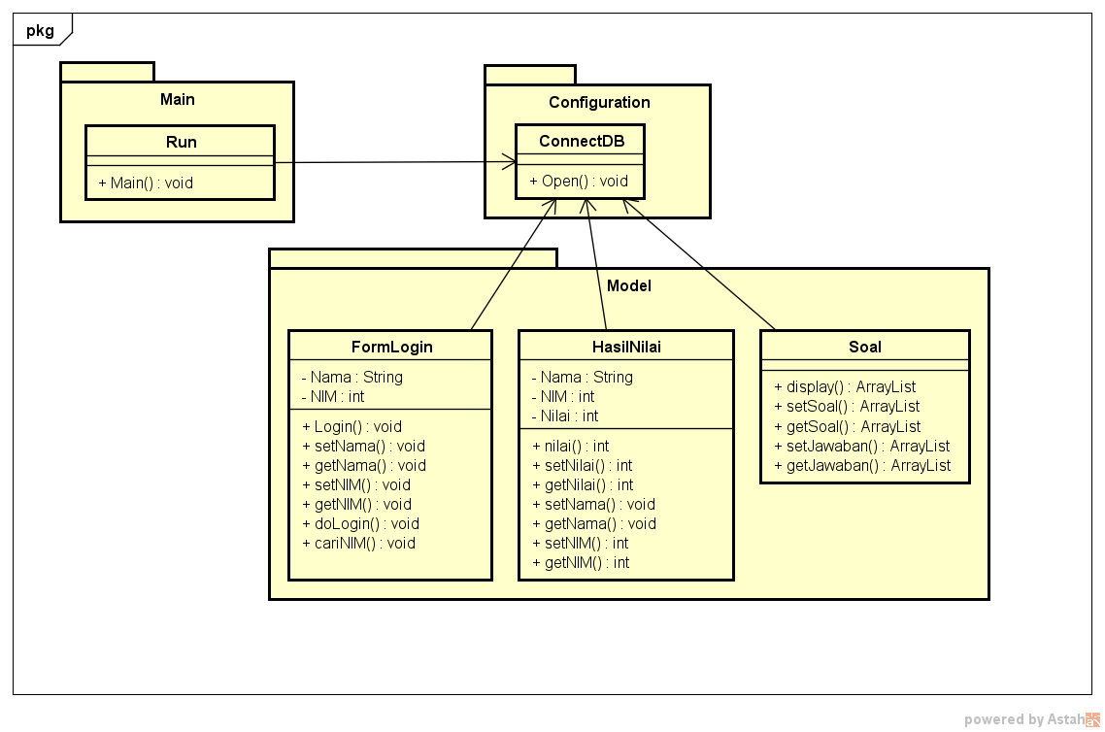

**CLASS DIAGRAM SERVER**

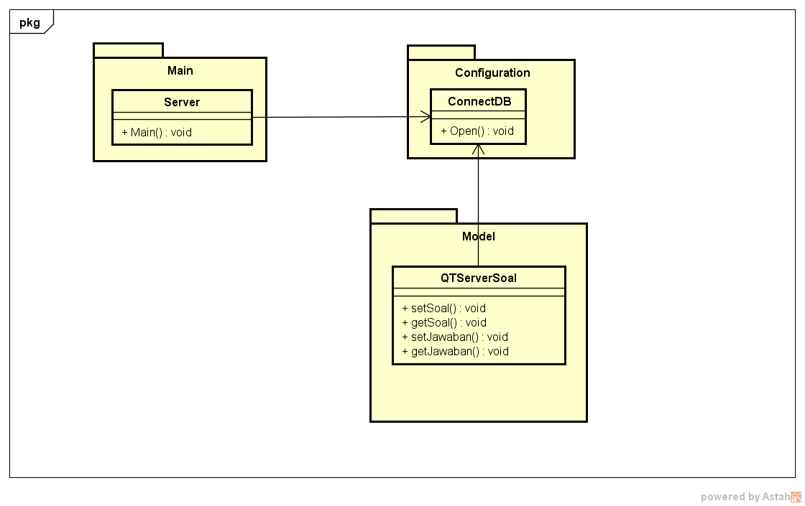

**DATABASE DESIGN**

**Database Name : DatabaseSoal**

**Number of Tables : 3**

**Tables Names :**

1. **tb_siswa**
2. **tb_soal**
3. **tb_nilai**

**E/R DIAGRAM FOR PSYCO TEST APPLICATION**

**Database Name :**

**E-R Diagram representing the relationship among various entities of the database.**

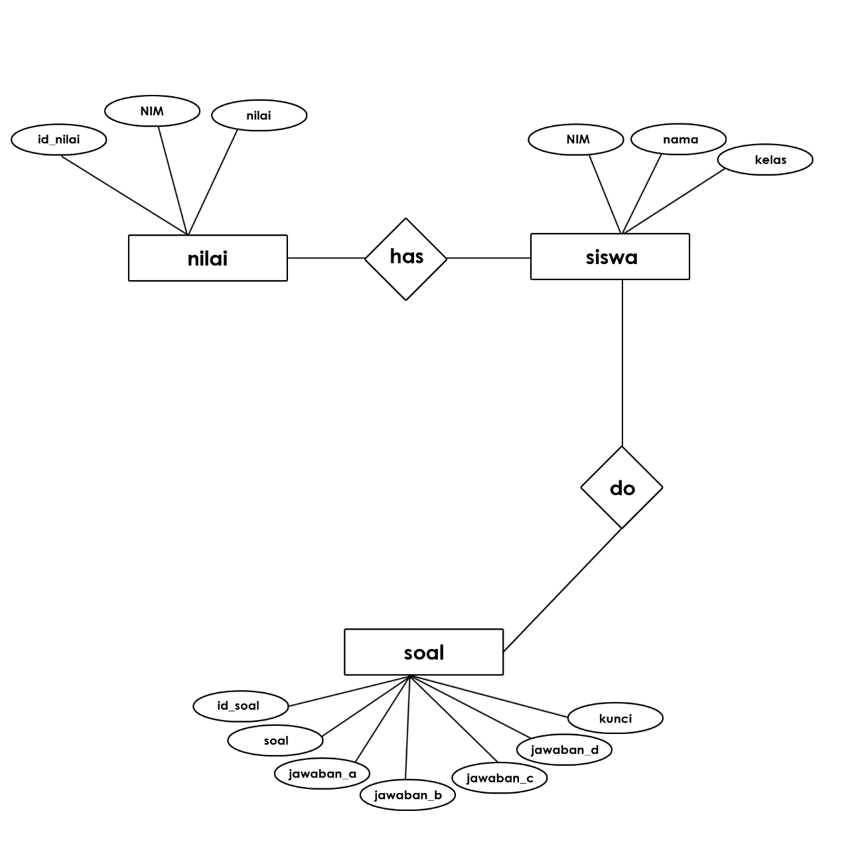

**TABLE DESIGN**

**Database Name :** SoalDatabase

**tb_siswa**

|  |  |  |  |
| --- | --- | --- | --- |
| ***Field Name*** | ***Data type*** | ***Width*** | ***Description*** |
| *NIM* | *int* | *50* | *ID of college student* |
| *Nama* | *varchar* | *20* | *Name of college student* |
| *Kelas* | *varchar* | *5* | *Class of college student* |

**tb_soal**

|  |  |  |  |
| --- | --- | --- | --- |
| ***Field Name*** | ***Data type*** | ***Width*** | ***Description*** |
| *Id_soal* | *varchar* | *50* | *ID of question* |
| *Soal* | *txt* | *-* | *Question* |
| *Jawaban_a* | *txt* | *-* | *The first multiple choice answer* |
| *Jawaban_b* | *txt* | *-* | *The second multiple choice answer* |
| *Jawaban_c* | *txt* | *-* | *The Third multiple choice answer* |
| *Jawaban_d* | *txt* | *-* | *The fourth multiple choice answer* |

**tb_nilai**

|  |  |  |  |
| --- | --- | --- | --- |
| ***Field Name*** | ***Data type*** | ***Width*** | ***Description*** |
| *Id_nilai* | *varchar* | *50* | *ID of score* |
| *NIM* | *int* | *50* | *ID of the college student* |
| *Nilai* | *varchar* | *50* | *Score of the test* |

**VALIDATION PERFORMED**

**tb_siswa**

|  |  |
| --- | --- |
| ***Validation Required*** | ***Method Used For Validation*** |
| *Nim (Nomor Induk mahasiswa) must be unique* | *Primary key constraint* |
| *Nama, Username, and Kelas field should not be blank* | *NOT NULL clause in the CREATE TABLE statement.* |

**tb_soal**

|  |  |
| --- | --- |
| ***Validation Required*** | ***Method Used For Validation*** |
| *Id_soal must be unique* | *Primary key constraint* |
| *Soal, Jawaban_a, Jawaban_b, Jawaban_c, and Jawaban_d field should not be blank* | *NOT NULL clause in the CREATE TABLE statement.* |

**tb_nilai**

|  |  |
| --- | --- |
| ***Validation Required*** | ***Method Used For Validation*** |
| *Id_nilai must be unique* | *Primary key constraint* |
| *NIM and Nilai field should not be blank* | *NOT NULL clause in the CREATE TABLE statement.* |

**LOGICAL FLOW DIAGRAM**

**Logical Flow Diagram representing the control flow of Psyco Test Application.**

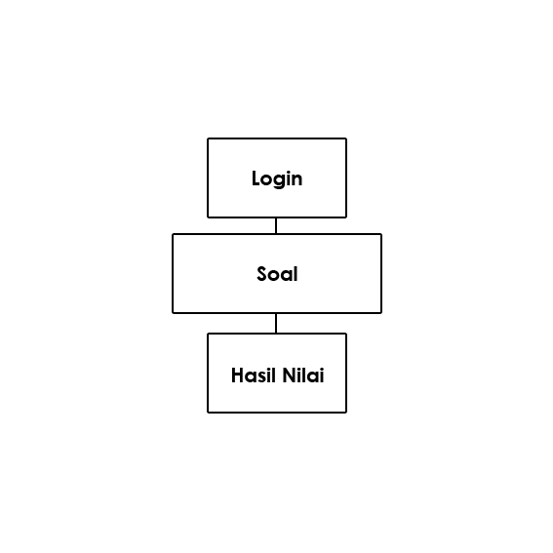

**\**

**FORMS OUTLINE**

|  |  |  |
| --- | --- | --- |
| ***Form Name*** | ***Description*** | ***Tables / Queries Used*** |
| *FormLogin* | *This form accepts the login credentials of the user and validates the login credentials with the database entries.* | *tb_siswa* |
| *Soal* | *This form accepts the answered questions and display a questions from the database entries* | *tb_soal* |
| *HasilNilai* | *This form is used to view the result of test* | *tb_nilai* |
| *SemuaNilai* | *This form is used to display the list of the all test has been done by all user* | *tb_nilai* |

**HARDWARE AND SOFTWARE REQUIREMENT**

**Hard**

**Hardware:** A node with Intel core i3 processor (1,6 Ghz or Higher), SCSI Hard disk of 500 GB, 2GB RAM, CDROM, intel graphic card, and 1-10/100 Mbps network card.

**Operating System:** Windows 7 Ultimate with SP3

**Software:** Netbean IDE 7.2, Microsoft Windows Ultimate Service Pack (SP), SQL Server 2005 Standard Edition, Microsoft Word 2013, and Astah Professional.

**PROJECT FILE DETAILS**

|  |  |  |
| --- | --- | --- |
| ***S.No*** | ***File Name*** | ***Remarks*** |
| *1* | *Main.java in QTServer Project* | *Beans that provides getter and setter methods for connecting the RMI Server to the SQL server database.* |
| *2* | *Main..java in QTClient Project* | *Beans that provides getter and setter methods for connecting the RMI Server to the SQL server database.* |
| *3* | *FormLogin.java in QTClient Project* | *RMI client Java application accepts username and password to access the application.* |
| *4* | *QTSoal.java in QTClient Project* | *RMI client Java application that accepts the answered data and saved to the database by invoking the remote method.* |
| *5* | *HasilNilai.java in QTClient Project* | *Java application that the score after the test has been done* |
| *5* | *QTInterface.java in QTInterface Project* | *RMI client Java application that accepts the transaction data and saves details in a database by invoking the remote method.* |
| *6* | *QTServerSoal.java in QTServer Project* | *Server Java application that accepts the data and saved to the database by invoking the remote method.* |

**PROJECT TIMELINES**

|  |  |  |  |
| --- | --- | --- | --- |
| ***Session*** | ***Module*** | ***Task to be performed*** | ***Time Limit*** |
| *1* | *Login and Menu Module* | *Creating the Login Form* | *20 minutes* |
| *Creating the Menu Form of the Application* | *20 minutes* |
| *2* | *Questioner Module* | *Creating form to answer the questions* | *1 minutes* |
| *3* | *Result Module* | *Creating the Result form to view the result test* | *20 minutes* |
| *4* | *Integrating, testing and debugging the application* |  |  |

**PROJECT DESIGN**

